Inspiring Ilango’s Brief Profile
7 facets: Inspiring Ilango has seven facets in terms of his career.
1. As the most sought after motivational public speaker Inspiring Ilango has been invited by corporate organizations, nongovernmental organizations, educational institutions and private and public forums in and out of India to bring about a paradigm shift in all aspects of life skills.
2. He's the professionally acclaimed singer, who can enthrall any audience with his motivational multilingual movie/non movie melodies. In other words he can instill among everyone the necessary impetus through his musivation.

3. As an entrepreneur Inspiring Ilango successfully runs a life skills training company called Ace Panacea Soft skills Pvt Ltd, which has three hundred trainers in its network. His team of trainers works towards fulfilling his vision of providing effective life skills training for corporate industries and educational institutions.

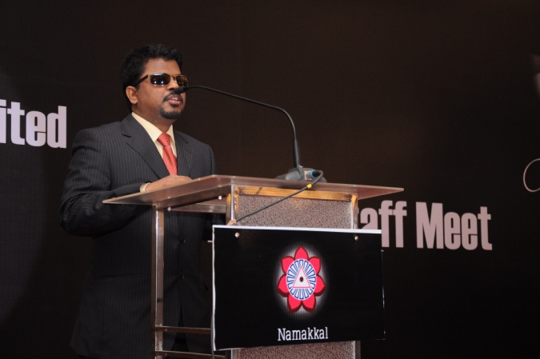

4. Inspiring Ilango is world’s only visually challenged voice-over artist. He has been rendering his mesmerizing voice for ad commercials, documentary films and short films.
5. Inspiring Ilango is the only visually challenged TV anchor in the world. He has anchored a unique musical chat show on Win TV.
6. Inspiring Ilango is a self development author, whose book, Jeyippadhu Nijam came to the book stalls on 14/01/2014. This book in Tamil has been selling more than twenty thousand copies so far.

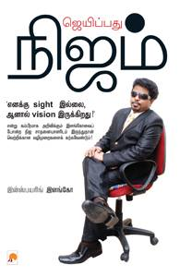

7. Inspiring Ilango is the brand ambassador of Namakkal Transport Carriers Pvt Ltd. He is the only visually challenged Brand Ambassador of an organization.

