Ace Panacea CMD Inspiring Ilango’s Profile

Inspiring Ilango is a dynamic and versatile professional, who believes that sky is the limit when it comes to exploring individual potentials. He has been excelling and making an indelible impression in seven careers. As an inspiring public speaker, enterprising entrepreneur, a self development author ,well-known voice - over artist, professional singer, unique TV anchor and the Brand Ambassador of Namakkal Transport Carriers.
He has the unique distinction of being the only visually challenged person, who has won accolades in the fields of music, voice-over, public speaking and business.
Ilango has completed his Masters in English with distinction from Loyola College, Chennai and has also done M.Phil in English Language Teaching from the University of Madras. He started his career as a school teacher and teacher trainer with TI Matriculation Higher Secondary School, Chennai and AMM School, Chennai. Subsequently he taught at Gurunanak College Chennai and university of Madras. His students are highly successful professionals today both in India and abroad.
He moved on to becoming the most sought after public speaker, voice-over artist and singer.

As an inspiring public speaker:
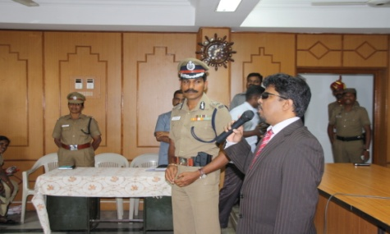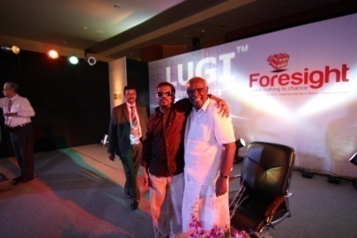

He has been invited by corporate companies, educational institutions, NGOs, TV Channels and general public forums to share his life inspiring story and motivate people on specific topics like Entrepreneurship, English for Empowerment, Self empowerment for Excellence, Leadership qualities, Happy Living, Healthy Relationships, Social Awareness and Effective Communication skills for Business and personal Success.
E.g., Standing Ovation by twenty five thousand people at the 13th& 35th Mega Tamil & English Convention’s of National Association of Malaysian Life Insurance Field Force and Advisor’s (NAMLIFA)-2011 & 2013 in Malaysia.

As a well-known voice-over Artist:
- He has been rendering his voice in both English and Tamil for ad commercials,

- Documentary / short films and multimedia Corporate Presentations. Signature Voice of Mega T.V, Captain T.V, and Chennai Live FM.

His is the voice behind several famous advertisements. Some of them are as follows

As a professional singer:

He has been a professional singer on stage and in recordings since 1995.

He possesses an astounding facet of being a passionate singer, who can sing over 3000 multilingual songs from memory. He has been performing in Tamil, Malayalam, Hindi and Telugu for Various occasions and visited many countries such as Dubai, Malaysia, Singapore and Thailand etc. Standing ovation by the audience is a certainty when the songs through his magical voice are blended and intertwined with his public address on sustained motivation.

As an enterprising entrepreneur:

Ace Panacea soft skills Pvt Ltd was founded by Inspiring Ilango with a relentless commitment to steer the human race towards the path of rapid progress and excellence by instilling and inculcating a value based prosperity among the youth. He has envisioned a mission of evolving each and every youth (be it a student, an employee, an executive, an entrepreneur) into a complete personality with a social commitment.
He has a network team of 300 trainers, who have been assigned with a mission to make a paradigm shift in attitude, skills and knowledge of innumerable entrepreneurs, executives, students, teachers, homemakers and professionals from all walks of life. His team of trainers works towards his vision of providing effective training by conducting an in-depth analysis of the needs of the educational institutions and corporate companies. His vision and drive have helped him earn the admiration of eminent trainers, who are proud to be associated with the Ace Panacea Brand or Brand Ilango. As the Chairman and Managing Director of ACE Panacea Soft skills Pvt Ltd, He has been setting new standards in empowering his fans with his highly energetic approach. A communicator par excellence, his constant quest is to tap the latent human potential and make every one embrace excellence. He considers himself to be the happiest man in the world as He makes everyone around him happy. "Be happy and make others happy" is his self created slogan. He has been a guiding force to thousands of youth.

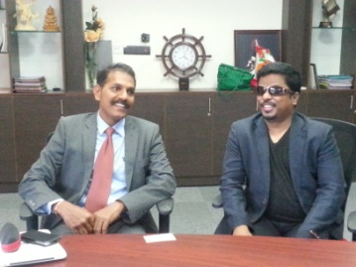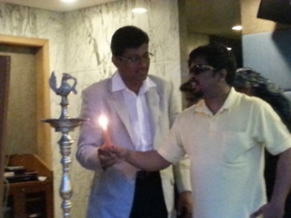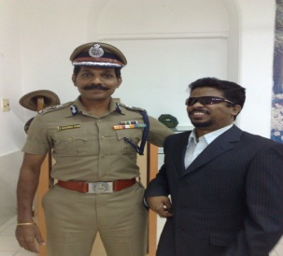

Ilango has proved by example that formal management degrees are not necessary to run a successful brand as long as a person has strong convictions, values and self confidence.

Ilango’s Mission and Vision Statement:
Mission:
To provide quality without compromise in the fields of training, entertainment and film making.

Vision:
Universal brotherhood is the ultimate solution through the world media, Ace Panacea

Modules developed by Inspiring Ilango:
- Life Skills.
- Effective Communication in English – ECE
- Faculty Enhancement Programme – FEP
- Aptitude skills.
- Employability Skills for Student Community.
- Emotional Intelligence in work environment
- Management Excellence in people management

Beneficiaries
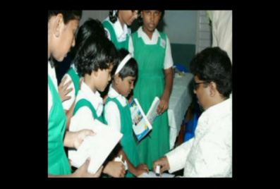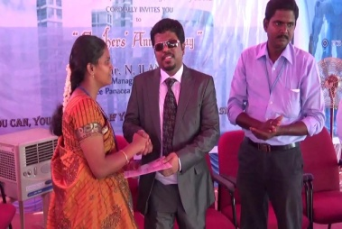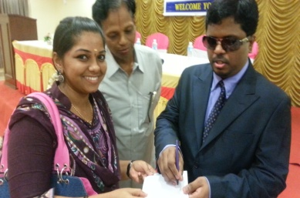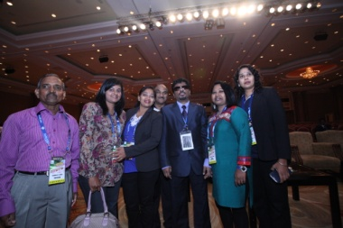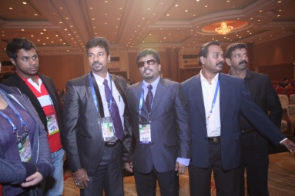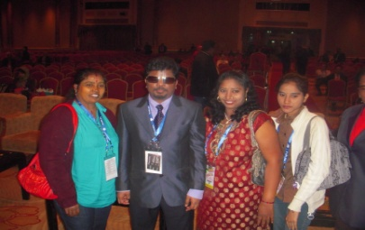
- Corporate Personal.
- Teachers and Students of educational institutions
- General Public.

Wings of ACE Panacea:

- ACE Pan Ads:
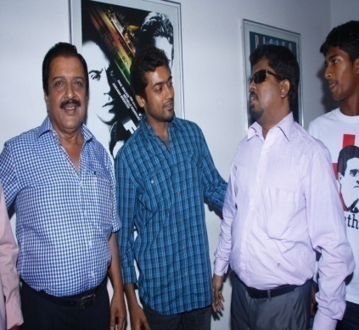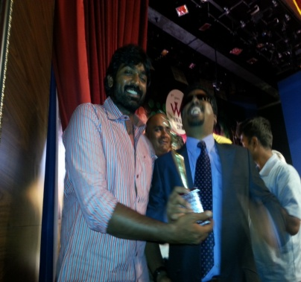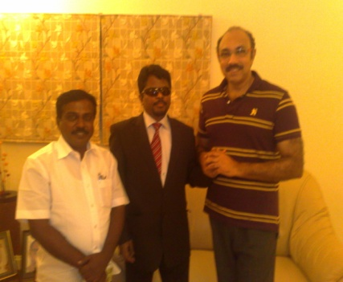

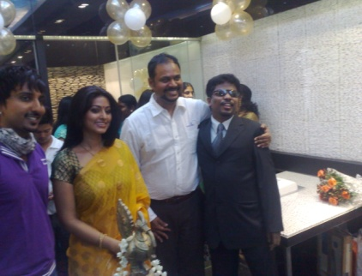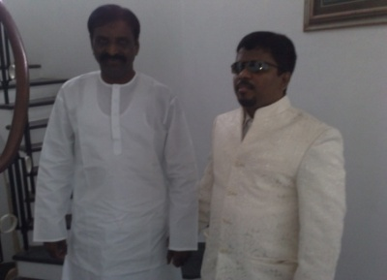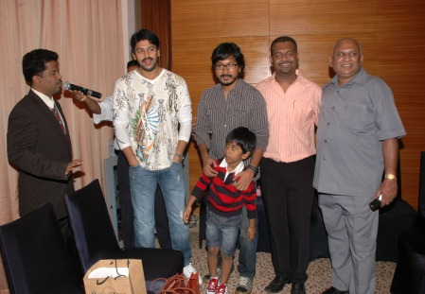

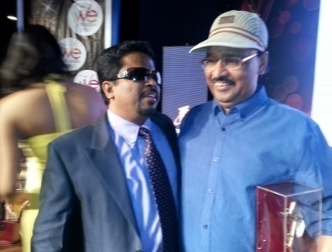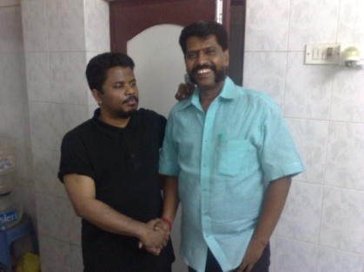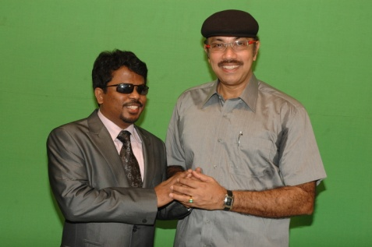
  - Advertisement films and Documentary films for corporate organizations and educational institutions

  - Brand promotional activities for corporate organizations and educational institutions

- ACE Entertainers:

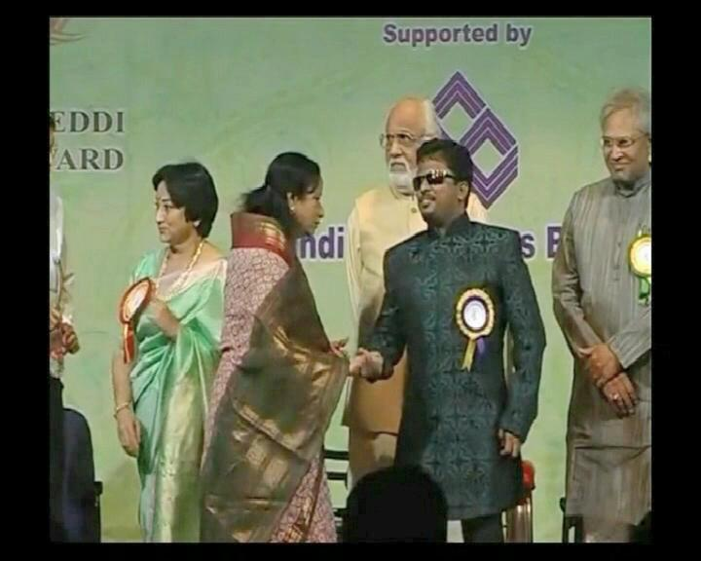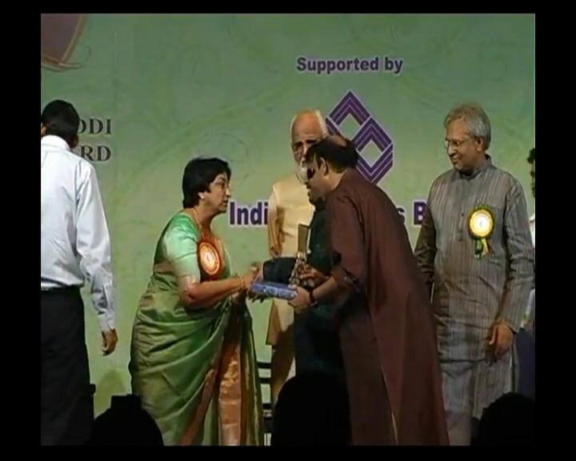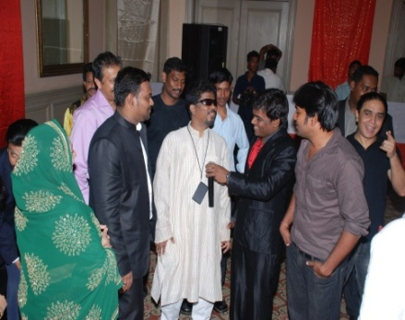

ACE entertainment division assists in conducting any get-together occasions such as college cultural, Inter\Intra collegiate Competitions, Birthday parties and Wedding receptions with Manual musician Support or without orchestra (professional karaoke performance)

As a self development author:
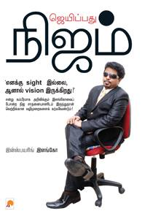
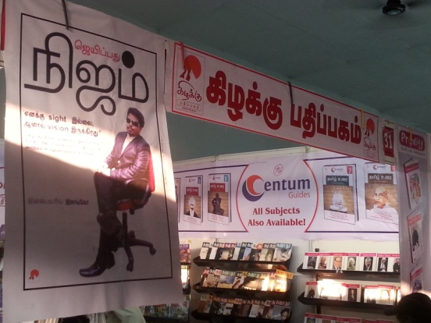
A self development book in Tamil Jeypadhu Nijam written by Inspiring Ilango and Published by Kizhakku Padhipagam came to the book fare in Chennai on 14th Jan 2014.

As a unique TV anchor:
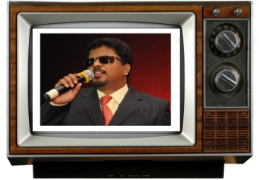
- Kangalum Kavi Paduthe a musical chat show in Tamil having Inspiring Ilango as an anchor had been on Win Tv every sunday 8pm-9 pm in 2012-2013

CURRENT POSITION:
Chairman and Managing Director–ACE PANACEA SOFT SKILLS PVT LTD

Nature of Business–Human resource Training Company

Brand Ambassador–

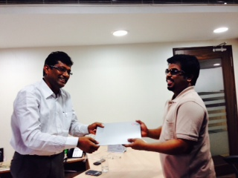
Nature of Business
Transport
Logistics
Engineering
Transport Education

Performance Ambassador–
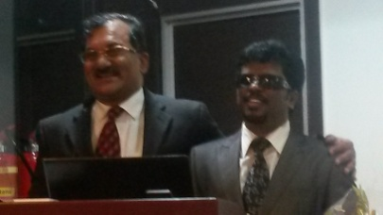
Nature of Business–Fire Equipment and Safety

Other Position:
- Honorary Member of Lions Club of Anbalaya District 324 A1.

AWARDS
- Invincible Willpower by Women Exclusive Awards- July 2013
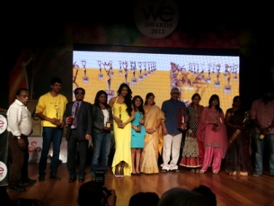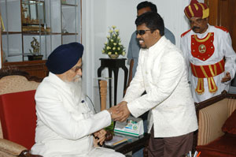
- “SEVAK OF THE YEAR” by World Family Foundation and Universal Sevak University Trust on 31 July 2011.

- Siva Foundation Award Best contribution to Music along with the playback Singer Mr.S.P,Balasubramaniyam on 21 June 2011

- “Tamil Nadu state government Award’’ - for being the Successful Employer and only visually challenged Voice over Artist, given by the Deputy Chief Minister Mr. M.K. Stalin, on 03 Dec 2010.
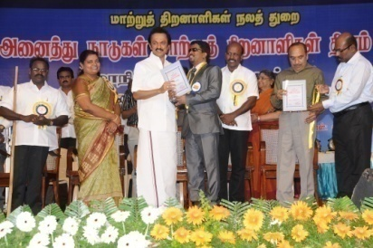
- “Rose of Rid van Award” by BAHAI’s assembly of Chennai on 25th April 2010
- OYI (Outstanding Young Indian) award by JCI, (National Level) on 27 December 2009
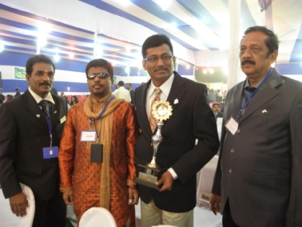
- OYP (Outstanding Young Person) award by JCI, (Regional Zone Level) on Nov 2009
- Selected as a YOUTH ICON by India Today in 2009
- Outstanding youth award’ by Rajiv Gandhi foundation in 2000.
- ‘Best Achiever Award’ at Loyola College in 1994.

Media Manifestations
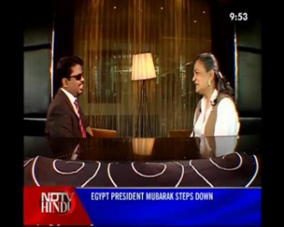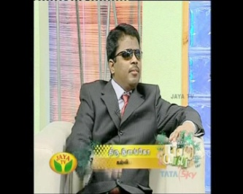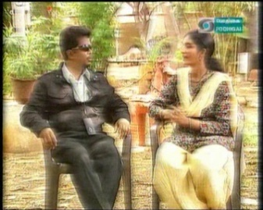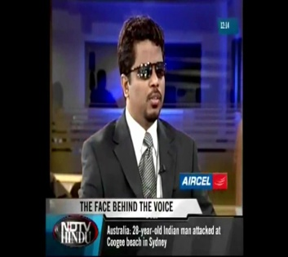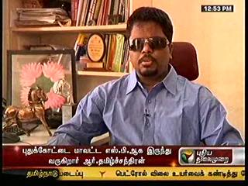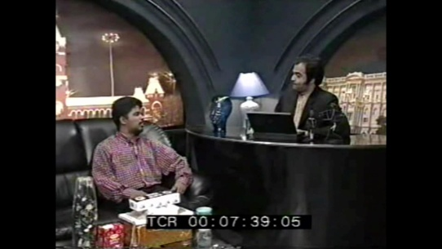
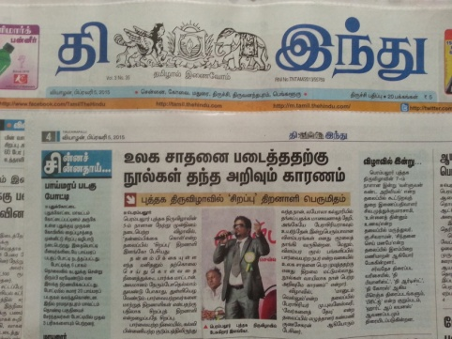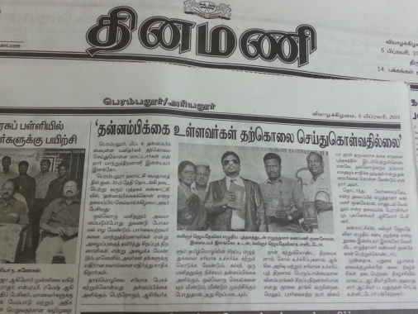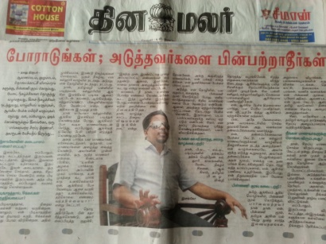
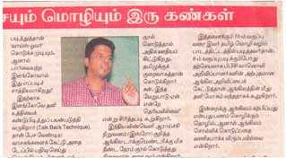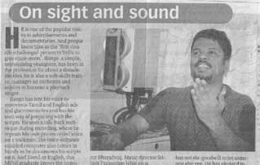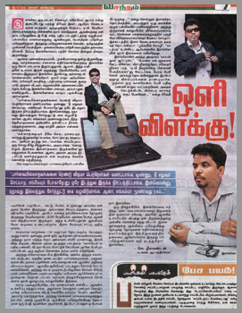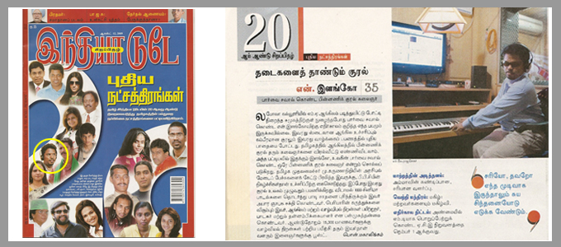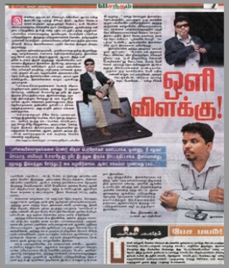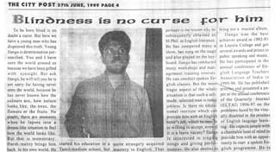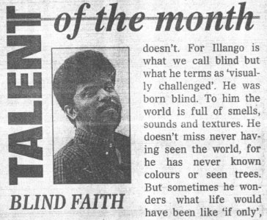

ILANGO,
Chairman and Managing Director,
ACE PANACEA SOFT SKILLS Pvt Ltd,

Visit us at: www.acea2z.com
Watch our videos on : http://www.youtube.com/user/acea2z/videos
Like us on : www.facebook.com/ilango.acepanacea
Follow us on :https://twitter.com/ilangoace
web : www.acea2z.com
Off :044-43313170,
Mob:+91-9941954545

"BE HAPPY AND MAKE OTHERS HAPPY"

